Deans Primary and Nursery School

Positive Relationship Policy

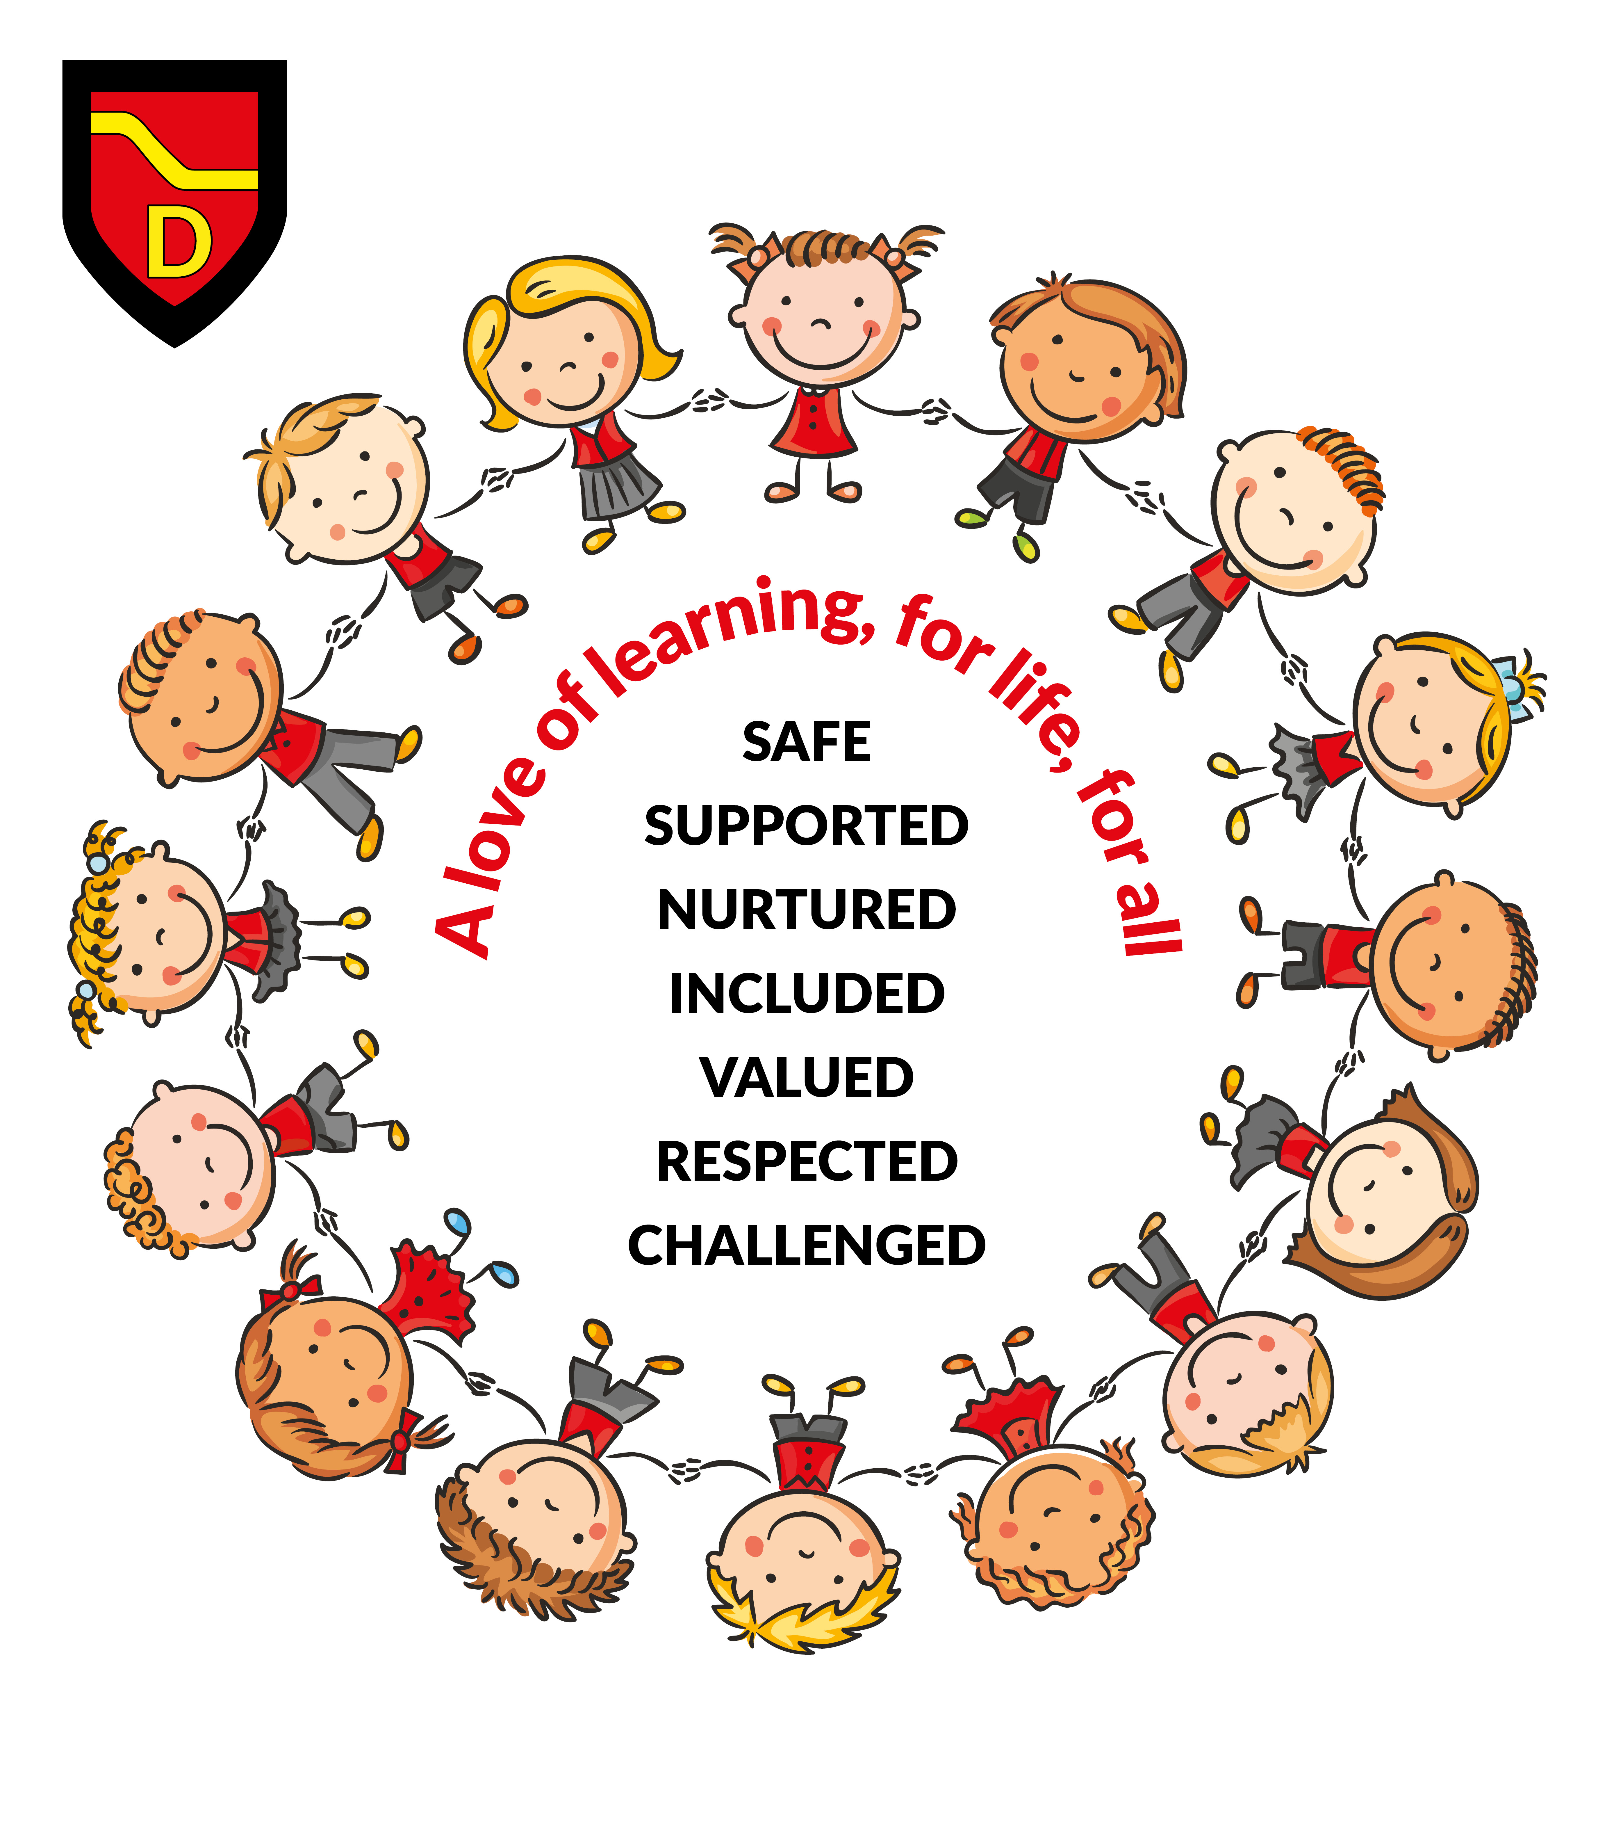
Rationale

At Deans Primary and Nursery School we strive to promote high standards of behaviour by ensuring that positive relationships are at the heart of all that we do in our school. Our Health and wellbeing curriculum continues to adapt to the needs of our pupils and school community. We strive to ensure that all members of our school community are involved in shaping our curriculum. We are committed to building and maintaining an ethos which is positive and supportive for all and where everyone feels valued and respected as equal members of our brilliant school community.

Our policy was originally created from discussion with all members of our school community through our Values Day, Staff August Inset and Pupil Focus Groups (August/September 2019) and developed August/September 2024 to reflect our evolving curriculum and focus on wellbeing. We continue to consult with all stakeholders around our policy as it is at the heart of our school community and is fundamental to the calm, nurturing and supportive ethos we have created and continue to maintain in our school.

Every member of our school community should:

Be greeted with a warm welcome, smile and given an opportunity to share their feelings.
Have a chance to learn and be inspired.
Have someone to notice if something is wrong and know where to get help if they need it.
Have someone to listen and believe in their dreams!

Aims

- To work alongside our parents, carers and local community in active partnership to develop and maintain positive relationships where all members trust, respect and support each other.
- To value all children as unique individuals who feel included and supported.
- To encourage children to develop self-discipline so that they learn to set their own goals and targets, challenging themselves to have high expectations for their own attainment and achievement: #DreamBigAtDeans
- To lead children towards being responsible and accountable for their actions and to support them to make the right choices.
- To build a culture where all members of our community feel valued, raising self-esteem, confidence and resilience with the creation of opportunities for recognising personal achievement in all areas.
- To help children manage their emotions by teaching them strategies that will have a positive impact on learning and social situations in a nurturing and safe environment.
- To be clear, consistent, firm and fair in promoting good standards of behaviour, built on positive relationships where we respect and value each other.
- To reflect Scottish Government Guidelines such as Getting it Right for Every Child (GIRFEC) by working with Outside Agencies such as Educational Psychologist; Outreach Services and Children and Young People Team to support specific needs of children.

All staff, pupils, parents, carers and members of our local community should feel Safe, Valued, Nurtured, Supported, Respected, Included and Challenged.

All members of our school community should have someone to talk to if this is not how they feel so they can be supported!



Responsibilities

All School Staff will:-
- Encourage greater involvement in the wider community in the school by welcoming volunteers into the school, organising meetings, workshops, developing our leadership pathway, Dream Big At Deans Skills Programme and events.
- Continue to acknowledge and celebrate all achievements through assemblies, points systems and certificates for achievements.
- Encourage the wearing of school uniform to foster a sense of pride, unity and belonging to the school.
- Have a shared responsibility for the maintenance of positive relationships throughout the school.
- Treat children with sensitivity, respect and understanding and model how children should treat each other.
- Recognise that some children require additional support with behaviour management through formal/informal behaviour support plans and formal Individual Education Plans developed in partnership with parents/carers and other relevant agencies.
- Establish good classroom organisation and routines which will encourage positive behaviour.
- Demonstrate and celebrate our school values at every opportunity.

Pupils will:-
- Work hard to achieve their learning and behaviour targets (through IEP’s and Child Planning Meetings).
- Be involved in the creation of Class and Playground Charters and reward systems at class and whole school level.
- Understand their rights and behave in a way that respects the rights of others.
- Be involved in restorative conversations to allow them to have their voice heard and help them reflect on their behaviour, taking responsibility for their actions and developing an understanding of how to deal with emotions differently.
- Have their successes celebrated and feel that their hard work and positive relationships are recognised.
- Do their best to demonstrate and uphold the school values at every opportunity.

Parents/Carers will:-
- Read and discuss class charters, our school positive relationship policy and school values with their child.
- Encourage appropriate behaviour both in school and in the community which reflect our school values.
- Work in partnership with the school and other agencies as appropriate, to address and resolve any difficulties which may arise.
- Demonstrate and celebrate our school values at every opportunity.
- Speak to a member of the Senior Leadership Team if there is anything happening at home which may impact on their child at school and require support.

- Ensure our children are in school every day and ready to learn.

How do we support and maintain positive relationships in Deans Primary and Nursery School?

- All members of the school community greet each other with enthusiasm to show that we are all valued and respected
- Senior Leadership Time spent with parents/carers at the start at end of the day (Tea and Chat sessions, drop in, time in the playground)
- Regular family learning opportunities
- Verbal praise for effort and achievement
- Weekly class ‘Together Time’
- Exciting class incentives built on praise and reward for following class charters
- Positive, constructive comments recorded in jotters and other work
- Visit to Senior Leadership Team for recognition (stickers/certificates etc.)
- Stickers, positive notes and certificates home
- Points for individuals, groups and whole class, bespoke to each class
- Points given for excellent behaviour, effort and upholding our school values

- Assemblies, Star awards, Values Champions and Magic Moments displays to publicise pupils’ achievements both in and out of school
- Munchies with Management
- Celebration of success at whole school assemblies
- Community Events
- Open communication with parents/carers (playground, beginning and end of day, ‘phone calls)

Strategy to support Positive Relationships in our school

What happens if our school values are not being followed in our classrooms and in the playground?

- Verbal/ Non-verbal Warning
- 5 minutes lost from Together Time where pupil will have the opportunity to speak to staff member about incident and create action plan for next time.
- 10 minutes lost from Together Time where pupil will have the opportunity to speak to staff member about incident and create action plan for next time.
- More than 10 minutes lost from Together Time during week – staff member to discuss with member of Senior Leadership Team (SLT). Member of SLT to meet with pupil for restorative conversation during course of the day. Minutes from conversation sent home to parents/carers to discuss at home.
- Unsafe behaviour – pupil to spend time with member of SLT during break or lunch time on that day where restorative conversation will take place to look at distressed behaviour and to put necessary supports in place. Minutes sent home to parents/carers to discuss with pupil at home.

For repeated or unresolved difficulties, the school Senior Leadership Team will be involved and some or all of the following strategies will be used to support the pupil:-

- Removal from class for a period of time to support and work through distressed behaviour identified
- Daily behaviour chart for an agreed period
- Involve parents in a home/school behaviour programme e.g. communications jotter;
- Removal from class to a supervised area with a member of support staff or leadership team
- Discussion with outside agencies
- Behaviour Support Plan/ Positive Response Plan initiated
- IEP /Assessment of Wellbeing/CPM initiated

For serious incidents we may bypass some or all of the previous steps and implement Formal Disciplinary procedures guided by West Lothian Council policy.

Formal Disciplinary Procedures: (To be guided by WLC policy)
- Short Term Exclusion;
- Long Term Exclusion

Bullying

Our Values of Safe, Nurtured, Included, Valued and Respected ensure that incidents of bullying are kept to a minimum.

At Deans Primary School, if any child alleges that they have been bullied, we take a number of steps to ensure that this allegation is taken seriously. Any allegation of bullying is investigated fully. Any founded bullying claims are logged on SEEMIS and communication with our parents/carers are key to ensuring that there is positive way forward and that children are supported through the process.

In our most recent Pupil Ethos Survey, there was an increase in positive responses, where our pupils felt that bullying was dealt with effectively in our school. 79% of pupils felt that bullying was dealt with effectively in our school which is above the West Lothian average. From restorative conversations, it is clear that we need to do some work as a school on the definition of bullying. This will be carried out through our assembly programme over the course of the session.

